**Week 8**

**Exercise-1 Hands-on: Git Basics**

**Objectives**

* Be familiar with Git commands like git init, git status, git add, git commit, git push, and git pull.

**Introduction to Git**

Git is a **version control system** that helps you track changes in your files. Think of it as a tool that takes "snapshots" of your project at different points in time, so you can always go back to a previous version if you need to. It's essential for collaboration and managing code projects.

**1.git -–version  
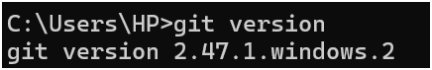**

**2.git config –global user.name “username”  
**

**3.git config –global user.email “email”  
**

**4.git config –global –list  
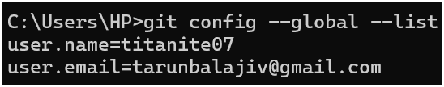**

**Add a File to Source Code Repository  
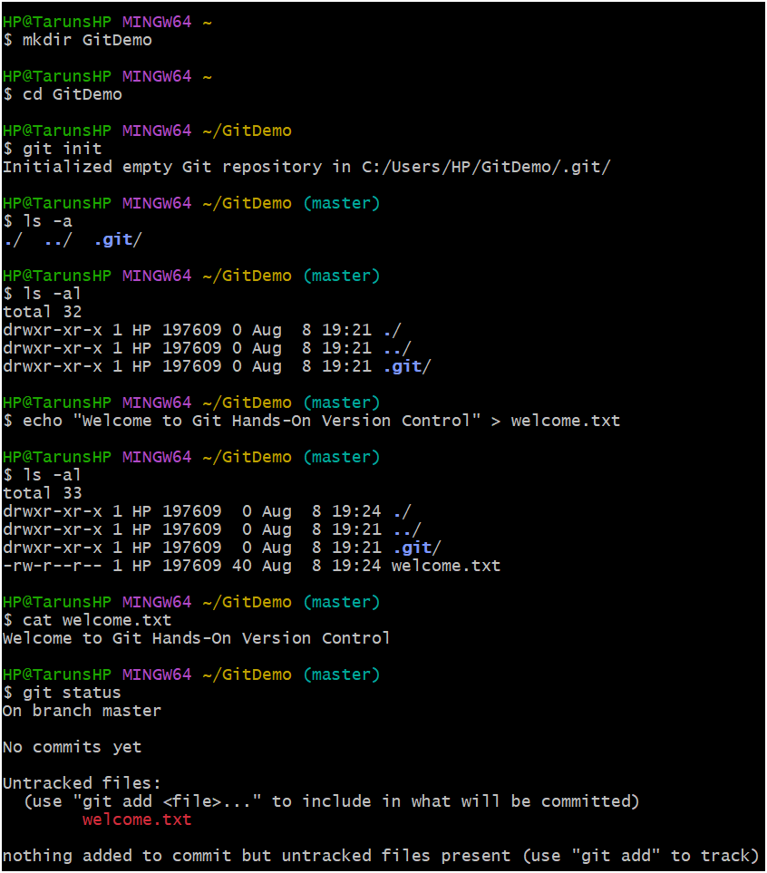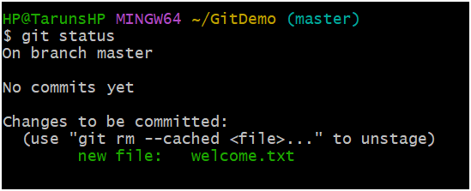**

**Exercise -2 Hands-On: Implementing .gitignore**

**Introduction to .gitignore**

When you're working on a project, there are often files you don't want to track with Git. These can include automatically generated files, temporary files, log files, or folders created by your operating system or IDE. The **.gitignore** file is a special text file that tells Git which files and folders to ignore. This keeps your repository clean and focused on the source code.

**Code:  
touch myapp.log  
mkdir log  
touch log/debug.log  
git status  
On Branch Master  
  
No Commits Yet  
  
Changes yet to be committed:  
 (use “git rm --cached <file>.. ” to unstage)**

**new file: myapp.log  
*.log  
log/  
git add .gitignore  
git commit -m "Add .gitignore to ignore log files and folders"  
git push origin master  
  
 Exercise -3 Hands-On: Introduction to Git Branching and Merging**

**Introduction to Git Branching and Merging**

Git **branching** allows you to work on different features or bug fixes in isolation from the main project. Imagine the main project as a tree trunk (master or main branch). When you want to work on something new, you create a new branch, like a new tree limb, so your work doesn't affect the stable "trunk" of the project.

Once your work on the new branch is complete, **merging** is the process of combining those isolated changes back into the main branch. This keeps the project history clean and allows multiple people to work on different things at the same time without interfering with each other.

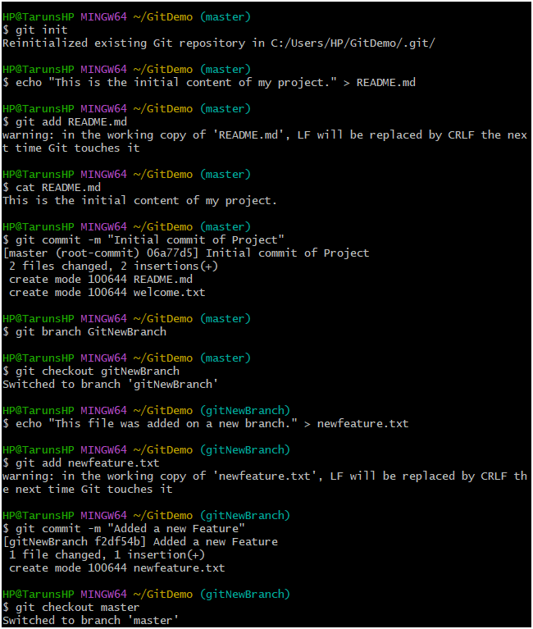

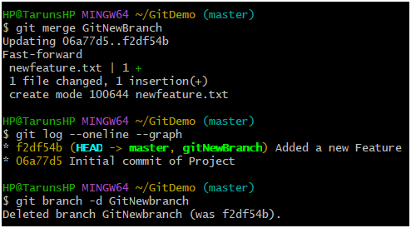

**Exercise -4 Hands-On: Understanding and Resolving Git Merge Conflicts**

A **merge conflict** occurs when Git is unable to automatically integrate changes from one branch into another. This typically happens when two different branches have modified the same lines in the same file, and Git can't decide which change to keep. Resolving conflicts is a fundamental part of collaborative work in a version control system like Git.

**1. The Scenario: Creating the Conflict**

To create a conflict, we need two separate commit histories that diverge from a common point.

* **Initial State:** Your project starts with a file (e.g., README.md) on the **master** branch.
* **Branching:** You create a new branch, GitWork, and switch to it using git checkout GitWork.
* **Divergent Changes:**
  + On the GitWork branch, you create a new file, hello.xml, and add some content. You then commit this change.
  + You switch back to the master branch (git checkout master).
  + On the master branch, you create a different version of the *same file*, hello.xml, and commit it.

At this point, Git's history has diverged. The master and GitWork branches both contain a hello.xml file, but with different content.

**2. The Failed Merge**

When you attempt to merge the GitWork branch back into master, Git will stop and tell you there is a conflict.

* **The Command:** You run git merge GitWork.
* **The Output:** Git will display a message like CONFLICT (add/add): Merge conflict in hello.xml. This means a conflict occurred because both branches added the same file with different content.

Git will then modify the conflicting file (hello.xml) with special markers to show you where the problem is.

**3. The Conflict Markers**

When you open the conflicting file in a text editor, you'll see a section that looks like this:

<<<<<<< HEAD

<?xml version='1.0' encoding='UTF-8'?><greeting>Hello from master!</greeting>

=======

<?xml version='1.0' encoding='UTF-8'?><greeting>Hello from the branch!</greeting>

>>>>>>> GitWork

* <<<<<<< HEAD: This marks the beginning of the conflicting change from your **current branch** (the HEAD of master).
* =======: This is the separator between the two conflicting versions.
* >>>>>>> GitWork: This marks the end of the conflicting change from the **branch you are merging** (the GitWork branch).

Your job is to manually edit this section to the final, correct version of the file, removing all of these markers.

**4. Resolving the Conflict**

To resolve the conflict, you must manually edit the file. There are a few options:

* **Accept your changes:** Delete everything between the ======= and >>>>>>> markers.
* **Accept their changes:** Delete everything between the <<<<<<< and ======= markers.
* **Combine both:** Edit the file to include elements from both versions. This is the most common approach.

In the example above, a good resolution would be to delete all the markers and combine the content:

<?xml version='1.0' encoding='UTF-8'?><greeting>Hello from the branch and the master!</greeting>

**5. Completing the Merge**

After manually editing the file, you need to tell Git that you've finished resolving the conflict.

1. **Stage the resolved file:** You add the file to the staging area with git add hello.xml. This tells Git that the conflict for this file is resolved.
2. **Commit the merge:** You run git commit -m "Merge branch 'GitWork' into master and resolve conflict". Git will automatically create a **merge commit** that records the new, final state of the file and completes the merge process.

**6. Cleanup: Deleting the Branch**

Once the GitWork branch has been successfully merged into master, you can delete it to keep your repository clean.

* **List branches:** Use git branch to see all local branches.
* **Delete the branch:** Use git branch -d GitWork. The -d flag is a safety measure; Git will only delete the branch if its changes have been fully merged into another branch. If you needed to force a deletion, you would use -D.

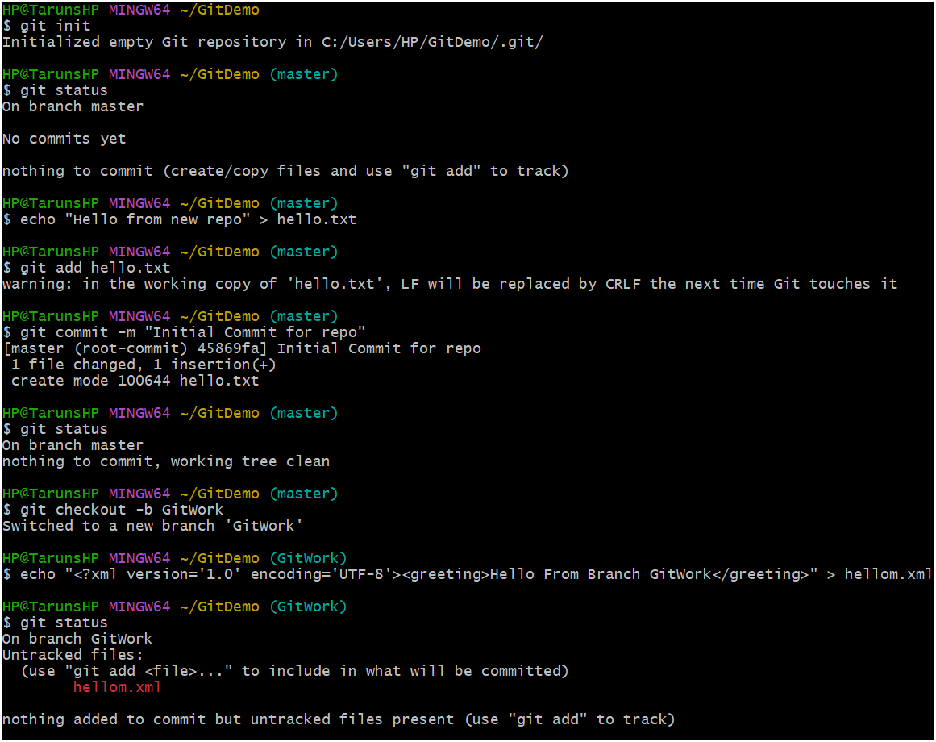

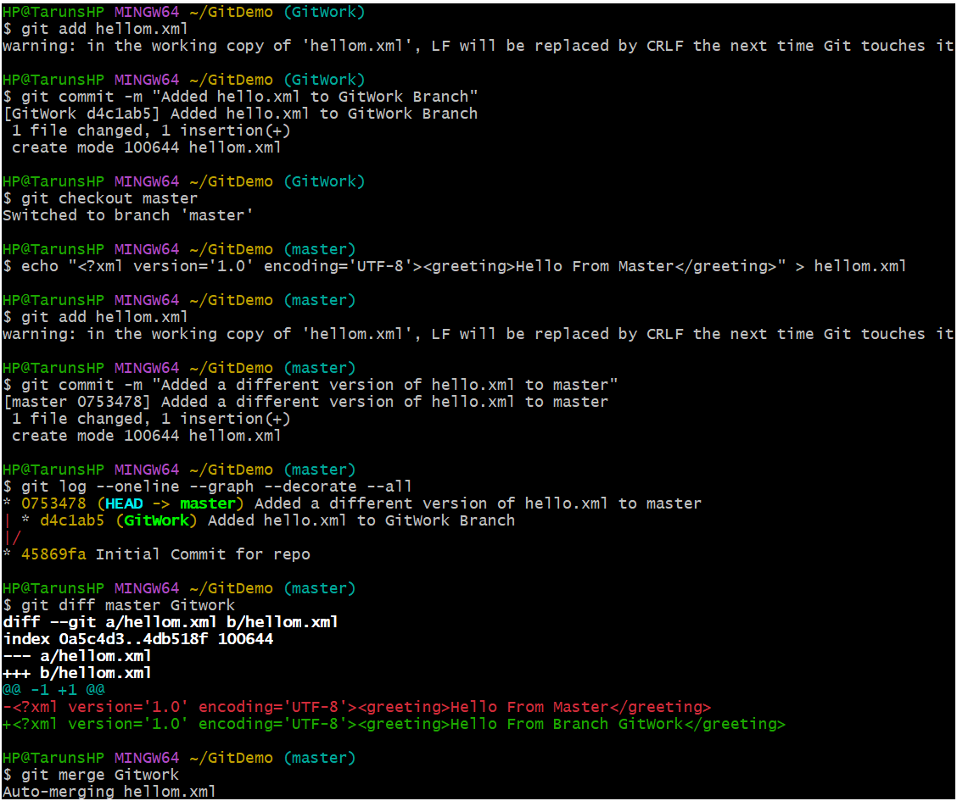

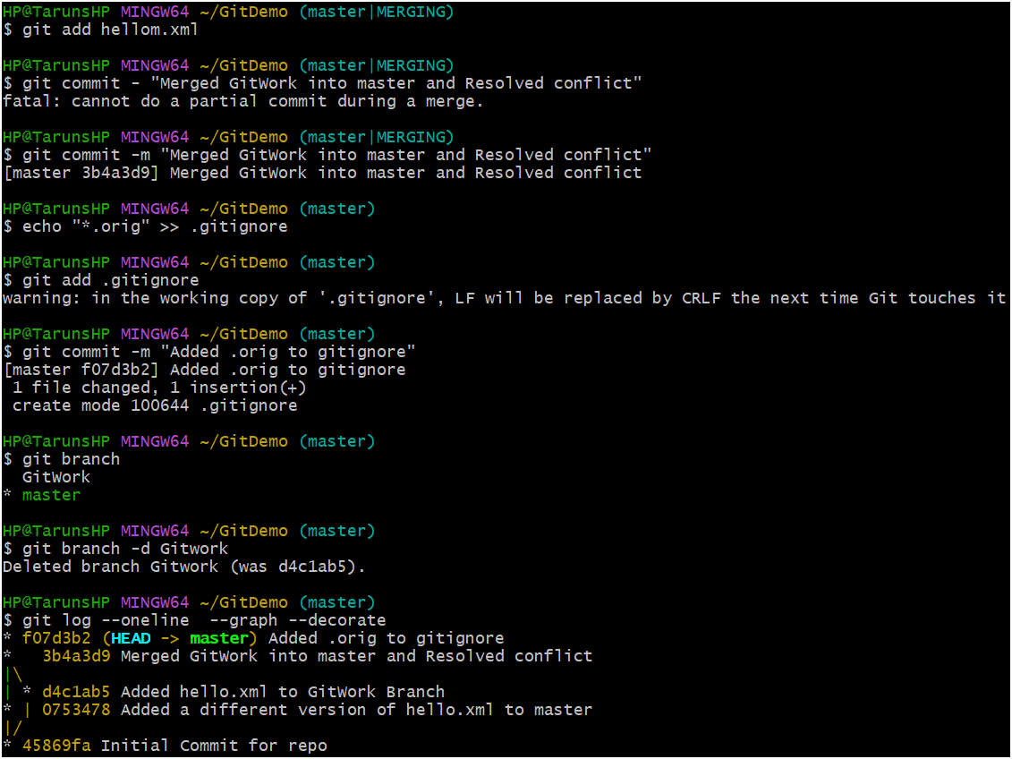

**Exercise -5 Hands-On: Pushing and Cleaning Up Your Git Repository**

**1. Verifying a Clean State**

Before you interact with the remote repository, it is always a good practice to check the status of your local working directory.

* **Command:** git status
* **Purpose:** This command shows you the state of your working directory and staging area.
* **Ideal Output:** You want to see nothing to commit, working tree clean. This means you have no uncommitted changes or unstaged files, so you can safely pull from or push to the remote repository without losing any work.

**2. Pulling the Latest Remote Changes**

Before pushing your changes, you should always pull any updates that others may have pushed to the remote repository since you last synchronized. This helps prevent merge conflicts.

* **Command:** git pull origin master
* **Purpose:** This is a shortcut for two commands:
  1. **git fetch origin**: This downloads the latest history from the remote repository (named origin). It updates your local copy of the remote branch but doesn't merge the changes into your current working branch.
  2. **git merge origin/master**: This merges the fetched changes from the remote master branch into your local master branch.
* **Result:** After a successful pull, your local master branch will be fully up-to-date with the remote version, and you're ready to push your own work.

**3. Pushing Local Changes to Remote**

Once your local branch is clean and has the latest changes from the remote, you can push your committed work to the shared repository.

* **Command:** git push origin master
* **Purpose:** This command uploads your local commits to the remote repository, making them available to your collaborators.
* **Understanding the terms:**
  + **git push**: The action of uploading your commits.
  + **origin**: The default name for the remote repository.
  + **master**: The name of the local branch you are pushing.
* **Result:** Your local master branch will now have the same commit history as the remote master branch.

**4. Verifying Changes on the Remote Repository**

The final step is to confirm that your changes have been successfully uploaded to the remote server.

* **How to verify:** You can't do this with a Git Bash command alone. You'll need to go to your Git hosting service's website (e.g., GitHub, GitLab, or Bitbucket) and navigate to your repository.
* **What to look for:** You should be able to see your new commit message and the updated files directly in the repository's file browser. This is your confirmation that the changes are live and visible to your team.

**git status**

**git pull origin master**

**git push origin master**